 | 20XX, Volume X, Issue Y｜ISSN 3105-899X｜eISSN 3105-9007

Microsoft Word Is Recommended for Editing.
Insert an Informative Article Title in Title Case: No More Than 20 Words
Given Name Family Name¹*, Given Name M. Family Name²
¹Department or School, Institution, City, Country
²Department or School, Institution, City, Country
Received  YYYY-MM-DD  Accepted  YYYY-MM-DD  Published  YYYY-MM-DD  Corresponding Author  Corresponding Author Name*  Email: email@example.com  DOI: https://doi.org/10.xxxx/xxxxx  Copyright 20XX by author(s)  This is an open-access article under the CC  BY 4.0 license (https://creativecommons.  org/licenses/by/4.0/).   | Abstract  Write a single paragraph of approximately 150–250 words. Begin by identifying the research context and specific problem, then state the objective or research question without broad claims. Describe the study design, setting, participants or sources, selection process, main measures or materials, and analytical approach; include the final sample size when applicable. Summarize the principal findings with concrete results, estimates, or themes that allow the reader to understand what was found. Distinguish supported from unsupported hypotheses and report important null findings when relevant. End with an interpretation and a practical or theoretical implication that follows directly from the results. Avoid using abbreviations unless they are widely recognized. Do not include citations, tables, figures, undefined terms, or claims not supported in the article. Replace this entire instructional paragraph with the actual abstract while retaining the paragraph style, font size, and alignment.  Keywords  Replace with 3–5 specific terms or short phrases. Capitalize the first letter of each keyword or phrase and separate them with semicolons, for example: Key concept; Method; Population.

1. Introduction
Introduce the topic, the specific problem, and the setting in which it arises. Summarize only the literature needed to establish what is known and what remains unresolved. State the article’s research aim, question, or hypothesis and explain its contribution. Replace this instructional text with the study’s own evidence-based prose. Keep the introduction as one section without subheadings unless a clear need makes them unavoidable.
Use APA 7 author-date citations for claims drawn from prior work. Write the introduction in connected paragraphs rather than a list of topics. Keep the Normal paragraph style, 12-point Times New Roman, justified, with no first-line indent. Replace this paragraph in place to retain its formatting.

2. Literature Review
Organize relevant studies by themes, theories, or findings rather than summarizing one source at a time. Compare areas of agreement and disagreement, identify the gap that motivates the present article, and show how the research question follows from the reviewed evidence. If the article is primarily theoretical, this section may be titled ‘Theoretical Background’ or another accurate equivalent.
In a literature review, write a book title in italic Title Case, for example, Research Methods in Education. Cite journal articles in author-date form, such as Smith and Lee (20XX) or (Smith & Lee, 20XX). Replace these examples with works listed in References.

2.1 Theme or Theoretical Framework
Replace this subsection with the first coherent theme or framework. Use a numbered subsection only when it helps readers follow the argument; delete unused levels. Keep citations and terminology consistent with the introduction and reference list.

2.1.1 Optional third-level heading
Use this third level only for a necessary subdivision of Section 2.1. Otherwise delete this heading and its instructional paragraph. Limit the manuscript to three numbered heading levels. Use sentence case for third-level headings: capitalize only the first word and proper nouns.

3. Methods
Describe the design and research setting, participants or sources, selection or sampling, materials or measures, procedure, and method of analysis in enough detail for readers to understand and assess the study. Adapt these elements to qualitative, quantitative, mixed-methods, review, or theoretical work without inventing steps that were not carried out.

3.1 Design and Data or Participants
State how the data or source materials were obtained, which cases were included or excluded, and the final analytic sample when relevant. Name any ethics approval or consent procedure here if it affects the methods; give the concise formal statement again under Ethics Statement.

3.2 Measures, Procedure, and Analysis
Define the main variables, instruments, coding steps, or analytical procedures that the study actually used. Replace or remove these subsection titles when a different division communicates the method more clearly.

3.2.1 Equations (if applicable)
When a formula is needed, enter it as editable text or an equation object, center it, and put its consecutive number at the right margin, as in (1). Refer to it in the text as Equation (1) and define all symbols below; delete this subsection if unused.
Y = a + bX (1)
Here, Y is the outcome, X is the predictor, and a and b are coefficients. Italicize variables; keep numbers, operators, units, and function names upright.

4. Results
Report findings and cite each table and figure by number before it appears, for example, “Table 1 summarizes ...” and “Figure 1 shows ...”. Keep table titles with their tables and figure captions with their images on the same page. Insert figures in line with text; interpret results in the Discussion.
Where relevant, present test statistics alongside the findings, for example: Mean scores differed between the groups, t(24) = 2.31, p = .029, 95% CI [.02, .44]. Italicize t, F, p, and r; keep df, CI, %, numbers, and operators upright.
Table 1. Replace with a brief, descriptive table title
Variable | Measure | Value
Enter item | Enter item | Enter value
Enter item | Enter item | Enter value
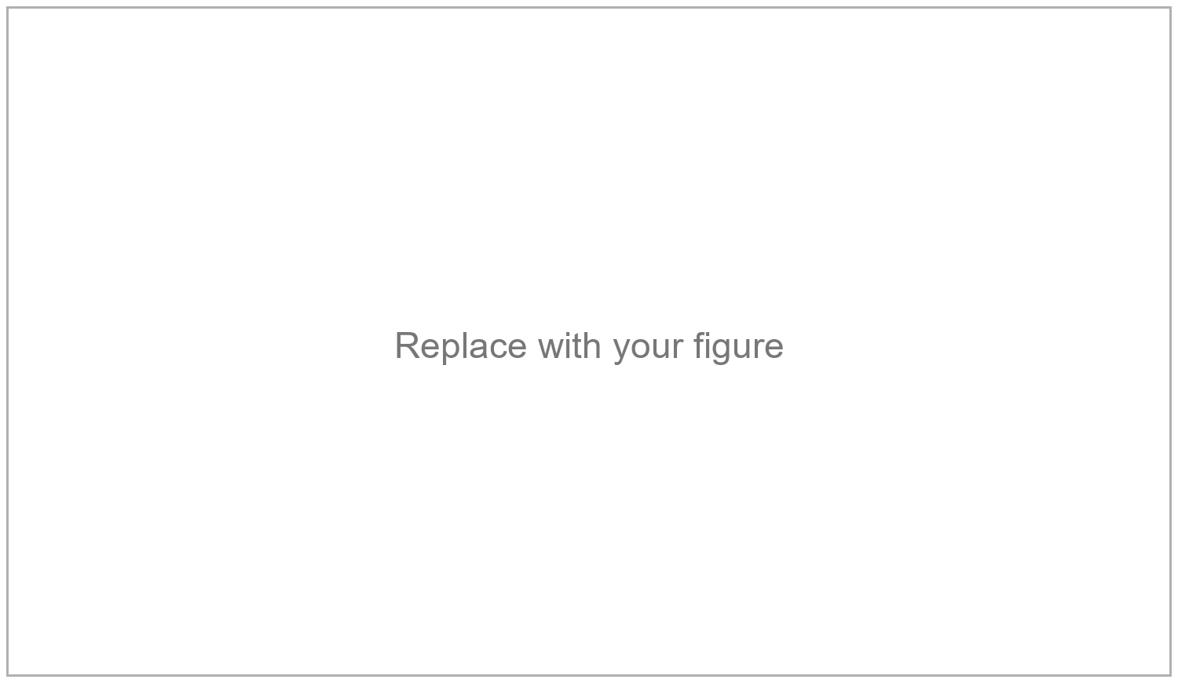
Figure 1. Replace with a brief, descriptive figure title

5. Discussion
Interpret the findings in relation to the research question and the literature reviewed in Section 2. Explain how the evidence supports the interpretation, discuss important limitations, and identify implications that follow from the results. Avoid repeating the Results section or introducing new analyses here.

6. Conclusion
End with a short statement of the article’s answer or contribution and, where appropriate, a specific implication or direction for future work. Replace this instruction with a conclusion supported by the preceding sections; do not introduce new evidence.

Acknowledgments
Name people or organizations that made a substantial contribution but do not qualify for authorship, and state the help provided. If there are no acknowledgments, replace this paragraph with: Not applicable.

Funding
State the funding agency, project title, and grant number when applicable. If there are multiple sources of funding, list each in a separate paragraph. If there was no funding, replace this paragraph with: There is no funding to report.

Conflicts of Interest
Disclose any actual or potential financial, professional, or personal conflicts. If there are none, replace this paragraph with: The author(s) declare no conflicts of interest regarding the publication of this paper.

Ethics Statement
Use only statements that are true. If applicable, add: The study was approved by COMMITTEE NAME (approval no. NUMBER; DATE). Delete inapplicable sentences. If ethics review was not required, write: Not applicable.
The study was conducted in accordance with appropriate ethical standards. Participation was voluntary, and informed consent was obtained from all participants. Participant anonymity and confidentiality were maintained throughout the study.

Data Availability
Choose one accurate option below and delete the others. Where possible, deposit questionnaires, coding schemes, datasets, and other supplementary materials in a stable repository and provide a persistent link here. Do not promise access that privacy, consent, law, or third-party rights prevent.
Public link: The study data and supplementary materials are available in Repository Name at https://example.org/data.
On request: The data supporting this study are available from the corresponding author upon reasonable request.
Restricted access: The data are not publicly available because sharing could identify participants. Requests may be directed to the corresponding author, subject to applicable restrictions.
No data: No datasets were generated or analyzed during this study.

References
Replace the examples below with cited works, one source per paragraph, alphabetized by first author's surname. Use sentence case for work titles and Title Case for journal names; retain the italics and hanging indent. Include a minimum of 20 references, with 40% or more published within the five years preceding submission. Include older seminal works when relevant.
Author, A. A., & Author, B. B. (20XX). Article title in sentence case: Subtitle also in sentence case. Journal Title in Title Case, 12(3), 101–118. https://doi.org/10.xxxx/xxxxx
Author, C. C. (20XX). Title of the book in sentence case (2nd ed.). Publisher Name.
Author, D. D. (20XX). Chapter title in sentence case. In E. E. Editor (Ed.), Title of the edited book in sentence case (pp. 45–62). Publisher Name.
Author, F. F. (20XX). Title of the doctoral dissertation in sentence case [Doctoral dissertation, University Name]. Repository Name. https://example.org/resource
Author, G. G. (20XX). Title of the data set in sentence case (Version 1.0) [Data set]. Repository Name. https://doi.org/10.xxxx/xxxxx
Organization Name. (20XX). Title of the report in sentence case (Report No. 123). https://example.org/resource
Writer, W. W. (20XX, Month Day). Title of the webpage in sentence case. Website Name. https://example.org/resource

Appendix A. Short Descriptive Title
Delete this optional page, including its page break, when no essential appendix is needed. Put questionnaires, datasets, and extended tables in linked supplementary materials (see Data Availability). If an appendix is necessary, replace this text with its content and cite Appendix A and any appendix tables and figures in the main text by number (for example, Table A1 and Figure A1). Use Appendix B for a second appendix; number its tables B1 and its figures B1.
Table A1. Short appendix table title
Column heading | Column heading
Essential content | Essential content
Figure A1. Replace with a brief, descriptive appendix figure title

